**PaNOSC**

**Photon and Neutron Open Science Cloud**

**H2020-INFRAEOSC-04-2018**

**Grant Agreement Number: 823852**



**Deliverable: D6.4 - Demonstration of the PaN software catalogue integration into EOSC - Support document.**

**Project Deliverable Information Sheet**

|  |  |
| --- | --- |
| Project Reference No. | 823852 |
| Project acronym: | PaNOSC |
| Project full name: | Photon and Neutron Open Science Cloud |
| H2020 Call: | INFRAEOSC-04-2018 |
| Project Coordinator | Andy Götz (andy.gotz@esrf.fr) |
| Coordinating Organization: | ESRF |
| Project Website: | www.panosc.eu |
| Deliverable No: | D6.4 |
| Deliverable Type: | Demonstrator |
| Dissemination Level | Public |
| Contractual Delivery Date: | 31 November 2020 |
| Actual Delivery Date: | 18/06/2021 |
| EC project Officer: | Simoni Misiti |

**Document Control Sheet**

|  |  |
| --- | --- |
| **Document** | Title: Demonstration of the PaN software catalogue integration into EOSC. |
| Version: 1.0 |
| Available at: |
| Files: 1 |
| **Date** | 4 April 2021 |
| **Authorship** | Written by: J-F.Perrin |
| Contributors: |
| Reviewed by: Rudolf Dimper, Jordi Bodera Sempere |
| Approved: Andy Götz |

**List of participants**

|  |  |  |
| --- | --- | --- |
| **Participant No.** | **Participant organisation name** | **Country** |
| 1 | European Synchrotron Radiation Facility (ESRF) | France |
| 2 | Institut Laue-Langevin (ILL) | France |
| 3 | European XFEL (XFEL.EU) | Germany |
| 4 | The European Spallation Source (ESS) | Sweden |
| 5 | Extreme Light Infrastructure Delivery Consortium (ELI-DC) | Belgium |
| 6 | Central European Research Infrastructure Consortium (CERIC-ERIC) | Italy |
| 7 | EGI Foundation (EGI.eu) | The Netherlands |

**Table of Content**

Summary 4

UmbrellaID integration 4

APIs 5

Conclusion 7

Software catalogue update

# Summary

The Photon and Neutron (PaN) software catalogue ( <https://software.pan-data.eu/> ) was created in 2012 to collect and provide a standard selection of different data processing and simulation software used in the community. The software in the catalogue can be freely consulted and downloaded. and provides an overview of software available for neutron and photon experiments, their use with respect to instruments at experimental facilities and information about their support.

In January 2020, in the scope of PaNOSC WP6, we launched a survey in the community to identify the most useful missing functionalities. User authentication through the community AAI (UmbrellaID) and a Rest API for interfacing where the two main requested functionalities. The result of the survey is available on the panosc wiki at:

<https://confluence.panosc.eu/display/wp6/2020-01+Functionalities+-+software+catalogue>

The ILL IT team was in charge of the development tasks linked to the upgrade of the software catalogue and which were expected to start in Spring 2020. Unfortunately, the COVID-19 crisis has constrained the Research Infrastructures to adapt quickly to travel restrictions and replace the traditional model of welcoming users on their site to perform the experiments by some form of remote experiment, or at least hybrid models where RIs’ local scientists prepare the instruments and users remotely control the experiments. The technical solutions and infrastructure to remotely control experiments were not ready at that time. RIs had to refocus their IT teams on providing solutions for authorising remote experiments. Regarding PaNOSC, this period has been beneficial for activities such as the development of a remote analysis portal in WP4, which has also been used for controlling remote experiments, but has slightly delayed less urgent work such as the upgrade of the software catalogue.

The development work took place during winter 2020-2021, the solution was rolled out in production in April 2021. The code of the application has been modernised to support container deployment (i.e. docker) and facilitate maintenance, and the two main functionalities necessary to integrate EOSC (AAI and Rest API) have been added.

# UmbrellaID integration

UmbrellaID is the PaN community AAI service since 2012. It was a relatively simple Infrastructure based on two Shibboleth Identity Providers (IdP).

Within PaNOSC we have built a strong relationship with GÉANT and adopted the eduTEAM service operated by GÉANT as the core infrastructure of UmbrellaID. This decision has largely facilitated the integration with the EOSC AAI model based on the AARC Blue Print Architecture (AARC BPA). Since then, we have extended the list of metadata available at UmbrellaID to match the EOSC requirements and to be able to solely base authentication and authorisation decisions on UmbrellaID for the software catalogue application.

As a result of this work, the software catalogue is fully ready for EOSC users who want to publish or update information about software of interest for the community.

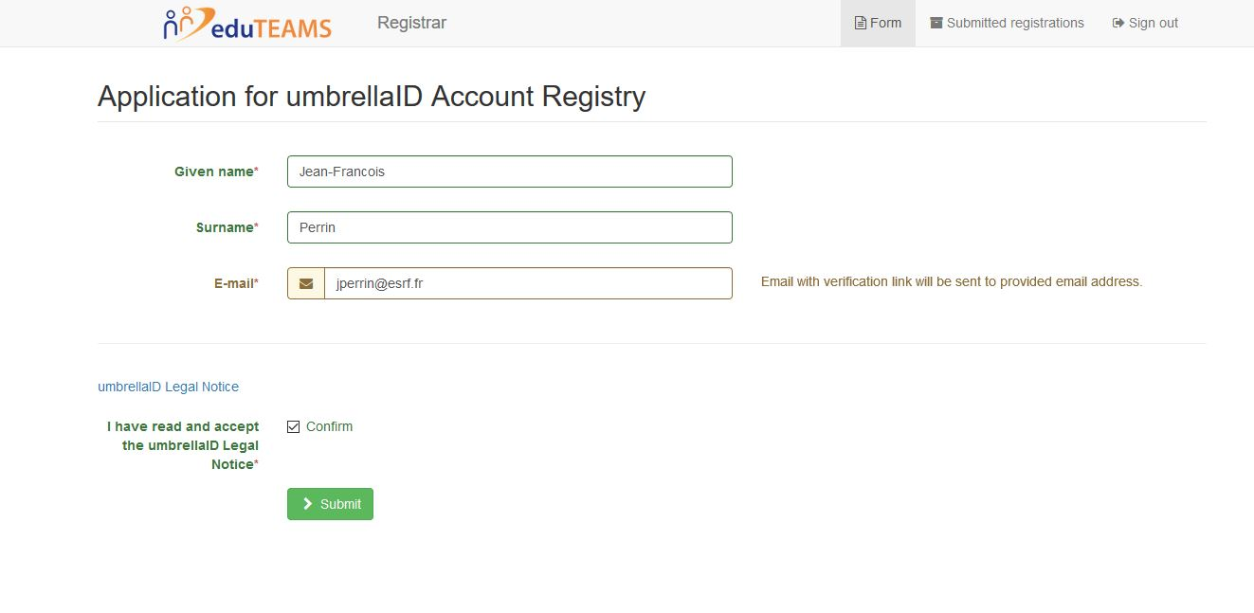

Figure 1 - UmbrellaID user metadata registration

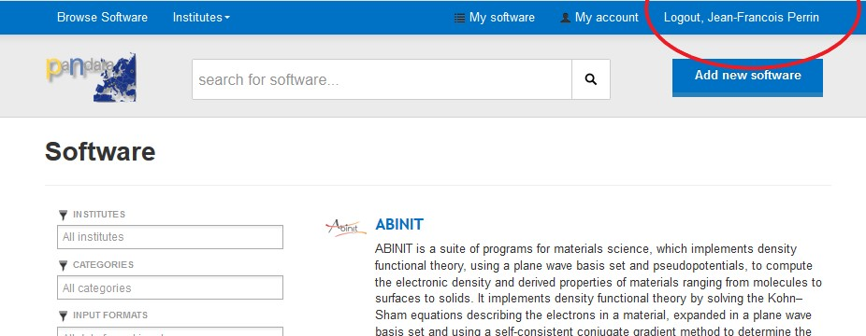

Figure 2- Software catalogue application taking benefit of the UmbrellaID integration

# APIs

Implementation of Rest APIs interfaces was requested during the survey. These APIs open the possibility to further exploit the service by linking to other catalogues. This is important for consolidating databases at the level of EOSC or in the community and allows to link with different data portals for being able to recommend analysis software to scientists downloading data.

Example of a simple request:

<https://software.pan-data.eu/api/software?q=neutron&institutes%5B%5D=1>

and the corresponding Json results:

|  |
| --- |
| {  "metadata": {  "pages": 1,  "page": 1,  "count": 8,  "hasNextPage": false,  "hasPreviousPage": false  },  "data": [  {  "name": "McStas",  "description": "A neutron ray-trace simulation package. McStas is a general tool for simulating neutron scattering instruments and experiments.",  "slug": "mcstas",  "platforms": [  { "id": 1,  "title": "Mac OS"  },{ "id": 2,  "title": "Linux"  },{ "id": 3,  "title": "Windows"  }  ],  "licenses": [  { "id": 419,  "title": "GNU General Public License 2.0"  }  ],  "languages": [  { "id": 3185,  "title": "C"  },{ "id": 3585,  "title": "Perl"  },{ "id": 3631,  "title": "Python"  }  ],  "outputs": [  { "id": 6,  "title": "NeXus"  },{ "id": 152,  "title": "m (MATLAB)"  },{ "id": 219,  "title": "R"  },{ "id": 278,  "title": "Text"  },{ "id": 295,  "title": "VRML"  },{ "id": 296,  "title": "VTK"  },{ "id": 302,  "title": "X3D"  }  ],  "inputs": [  { "id": 278,  "title": "Text"  }  ],  "logo": {  "id": 53,  "relativePath": "uploads/software/logos/588b6216c4f16.png"  },  "instruments": [],  "categories": [  { "id": 1,  "title": "Instrument Simulation"  },{ "id": 3,  "title": "Sample simulation"  },{ "id": 9,  "title": "Optics simulation"  },{ "id": 13,  "title": "Powder Diffraction"  },{ "id": 14,  "title": "Single Crystal Diffraction"  },{ "id": 19,  "title": "Spectroscopies"  }  ],  "institutes": [  {  "id": 1,  "name": "ILL",  "printableName": "ILL"  }  ]  },  […] |

# Conclusion

The PaN Software Catalogue is an important component for the implementation of FAIR data in all PaN RIs. The added features of UmbrellaID AAI and Rest API will allow easy integration to EOSC to make it available to a much wider user community. Continued effort has now to be made to ensure that the software catalogue is enriched with additional software packages used for processing data from the PaN RI data catalogues.